Terraform Task -05

Overall Task Title
Provision an EC2 Instance with Apache (httpd) Using Terraform with Remote State Management (S3 Backend & DynamoDB Locking)
Objective
To understand and implement Infrastructure as Code (IaC) using Terraform by:
- Creating an EC2 instance with Apache (httpd) installed
- Automating configuration using user_data
- Storing Terraform state remotely in Amazon S3
- Enabling state locking using Amazon DynamoDB
- Ensuring safe, scalable, and collaborative Terraform executions
Prerequisites
- AWS Account with required permissions
- AWS CLI installed and configured (aws configure)
- Terraform installed on local machine
- Visual Studio Code (or any IDE)
- Basic knowledge of:
  - AWS EC2, S3, DynamoDB
  - Terraform commands (init, plan, apply)
  - Linux basics and Apache (httpd)

Execute the script shown in the video.
Task Title
Provisioning AWS Infrastructure and EC2 Instance Using Terraform
Objective
To create and manage AWS resources using Terraform, including:
- S3 bucket creation
- DynamoDB table creation
- Terraform backend initialization
- EC2 instance provisioning
- Verification of resources in the AWS Management Console
- Capturing EC2 public IP using a provisioner
Prerequisites
- AWS account with valid credentials
- AWS CLI installed and configured
- Terraform installed
- Visual Studio Code installed
- Existing AWS key pair (NV / sshless)
- Internet access
- Permissions for EC2, S3, DynamoDB, and VPC
Steps Performed:
Step 1: Create an S3 Bucket Using Terraform
- Defined an aws_s3_bucket resource in main.tf
- Used a unique bucket name (s3carbucket)
- Applied the configuration using terraform apply
- Terraform successfully created the S3 bucket
- Verified the bucket in AWS S3 Console (visible in Europe – Stockholm region)
Step 2: Observe Deprecated ACL Warning
- Terraform displayed a warning that acl = "private" is deprecated
- Warning acknowledged; resource creation continued successfully
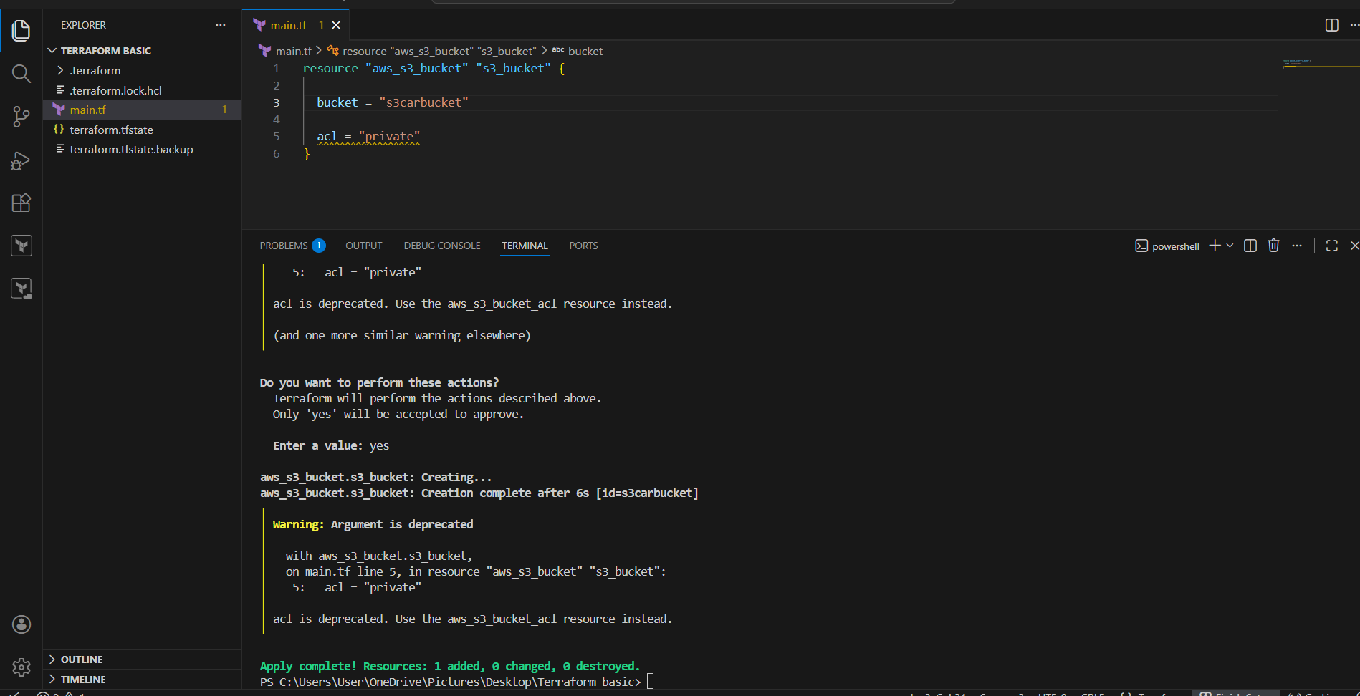

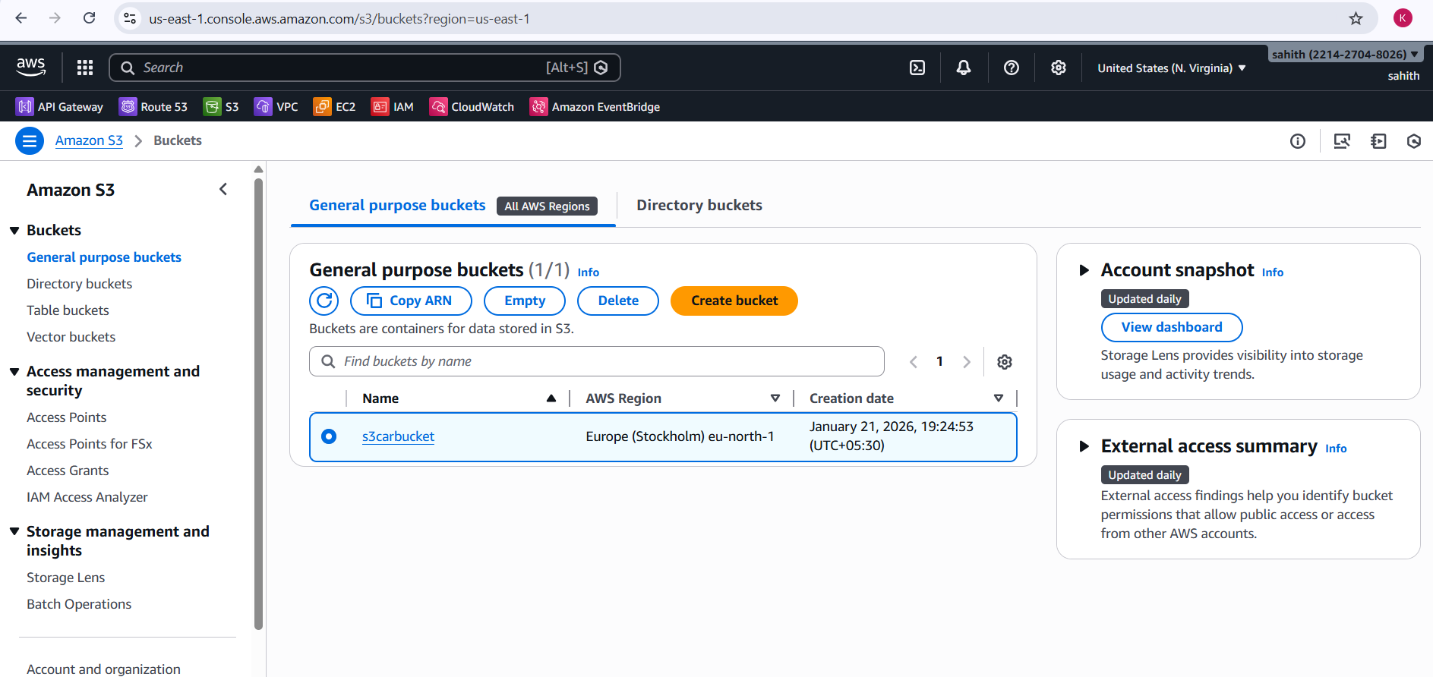
Step 3: Create DynamoDB Table Using Terraform
- Added aws_dynamodb_table resource
- Table name: terraform-state-lock-dynamo
- Partition key: LockID (String)
- Read/Write capacity set to 20
- Executed terraform apply
- DynamoDB table creation completed successfully
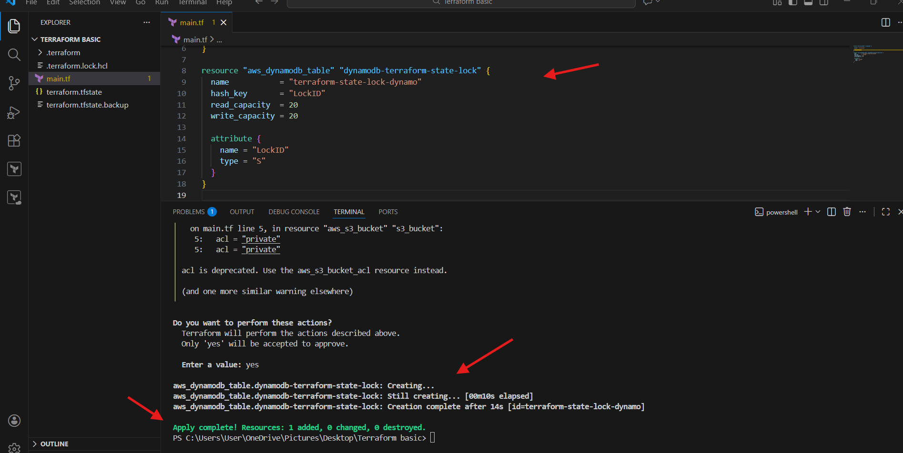
Step 4: Verify DynamoDB Table in AWS Console
- Navigated to DynamoDB → Tables
- Confirmed table terraform-state-lock-dynamo exists
- Status shown as Active
- Partition key correctly configured as LockID
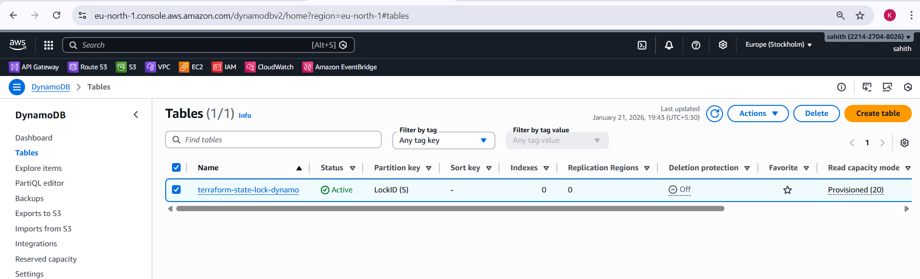
Step 5: Configure Terraform Backend (S3 + DynamoDB)
- Added terraform { backend "s3" { ... } } block
- Configured:
  - S3 bucket for state storage
  - DynamoDB table for state locking
  - Region set correctly
- Ran terraform init
- Backend initialized successfully
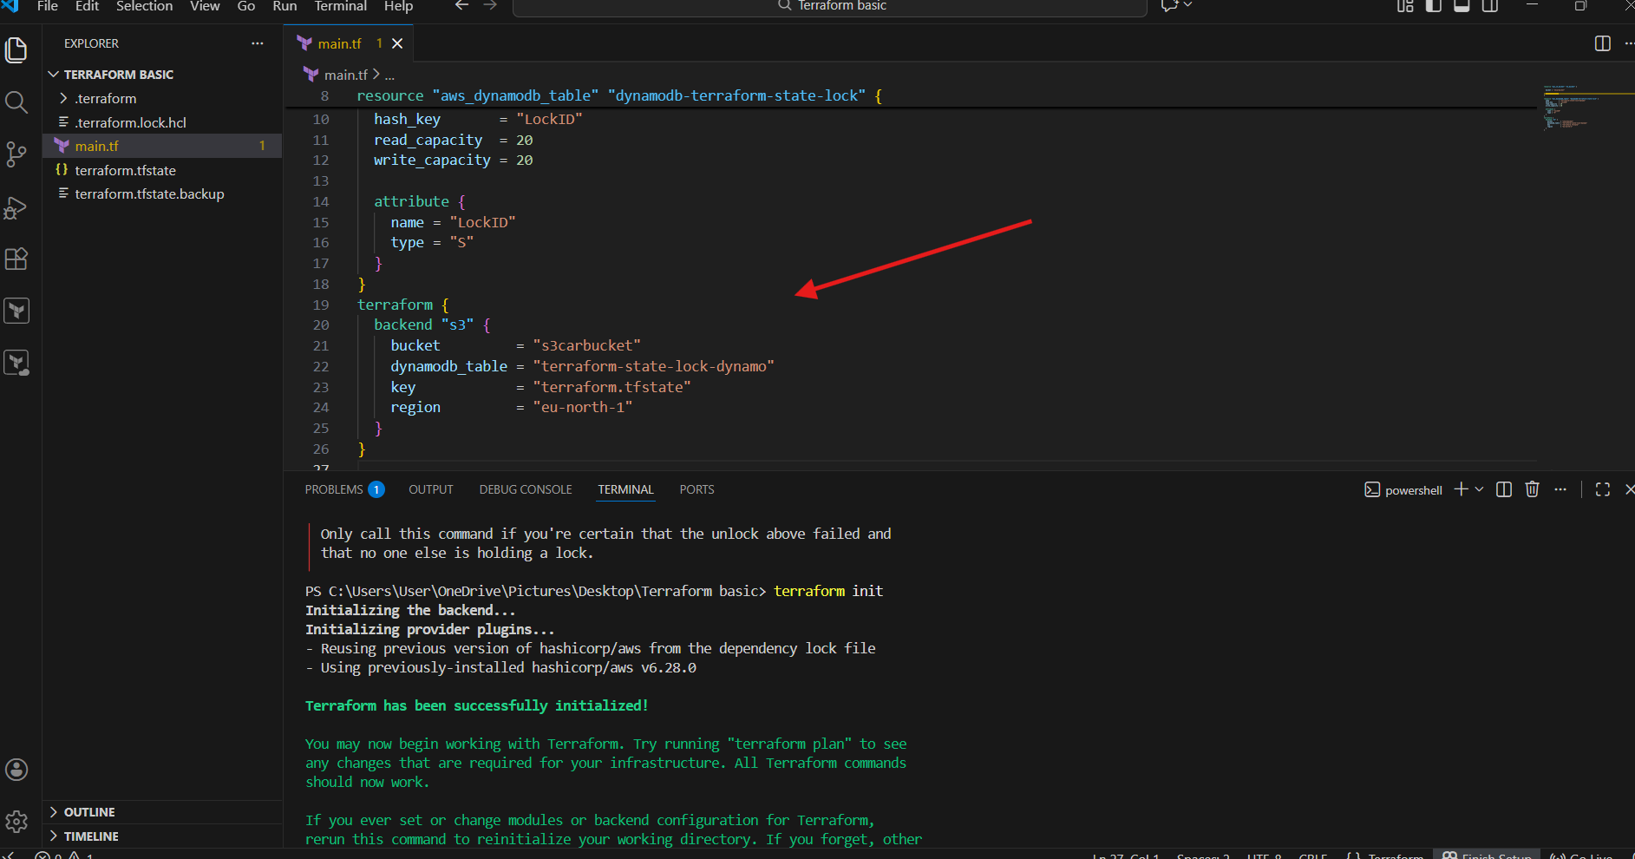
Step 6: Define EC2 Instance Resource
- Added aws_instance resource in main.tf
- Configured:
  - AMI: Amazon Linux 2023
  - Instance type: t3.micro
  - Key pair: NV
  - Tags for identification
Step 7: Apply Terraform to Create EC2 Instance
- Executed terraform apply
- Terraform created the EC2 instance successfully
- Instance creation completed without errors
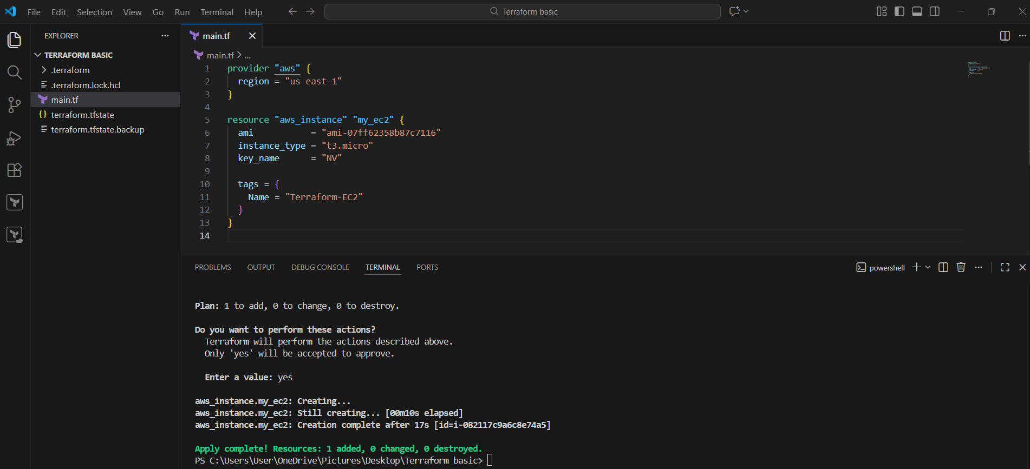
Step 8: Verify EC2 Instance in AWS Console
- Navigated to EC2 → Instances
- Confirmed instance named Terraform-EC2
- Instance state shown as Running
- Instance type verified as t3.micro
- Region confirmed as us-east-1
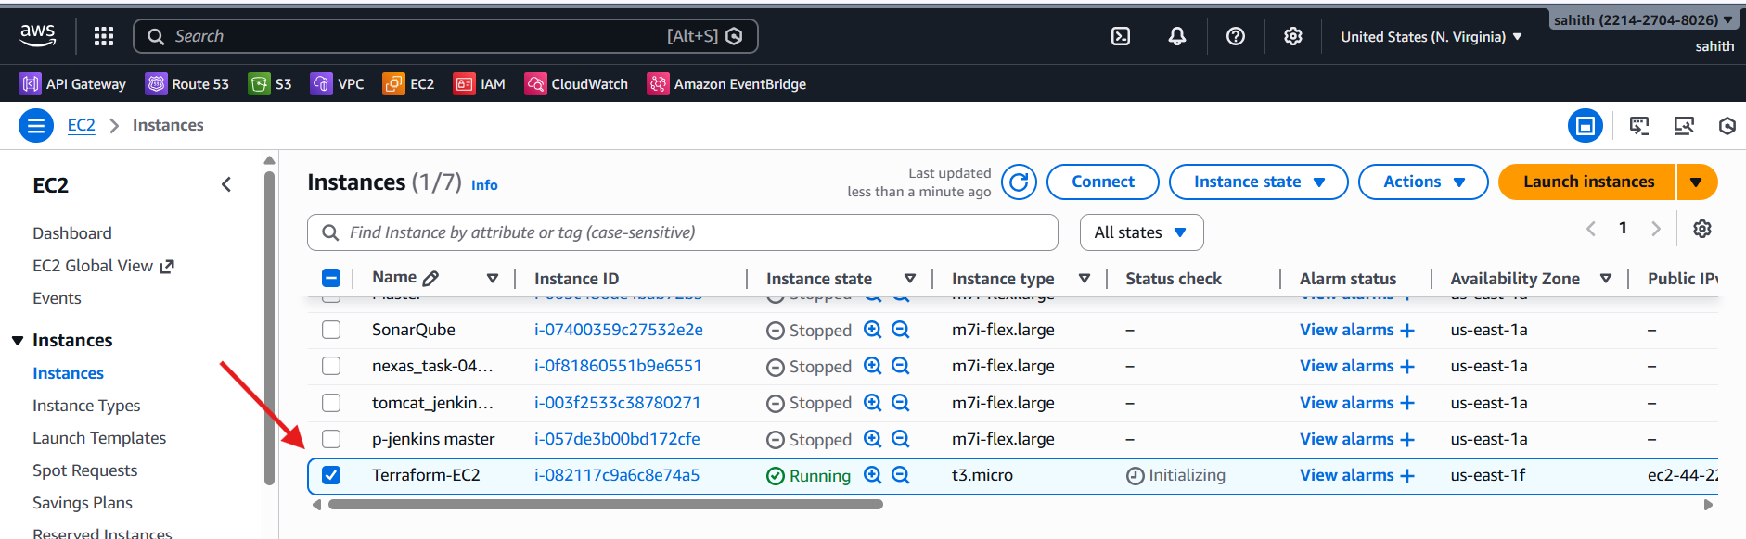
Step 9: Update EC2 Configuration with Local-Exec Provisioner
- Added local-exec provisioner to EC2 resource
- Provisioner command writes EC2 public IP to a local file (ip_address.txt)
- Re-ran terraform apply
- Terraform recreated the EC2 instance as expected
Step 10: Capture EC2 Public IP
- Terraform executed the local command successfully
- ip_address.txt file generated in the project directory
- File contains the public IP of the EC2 instance
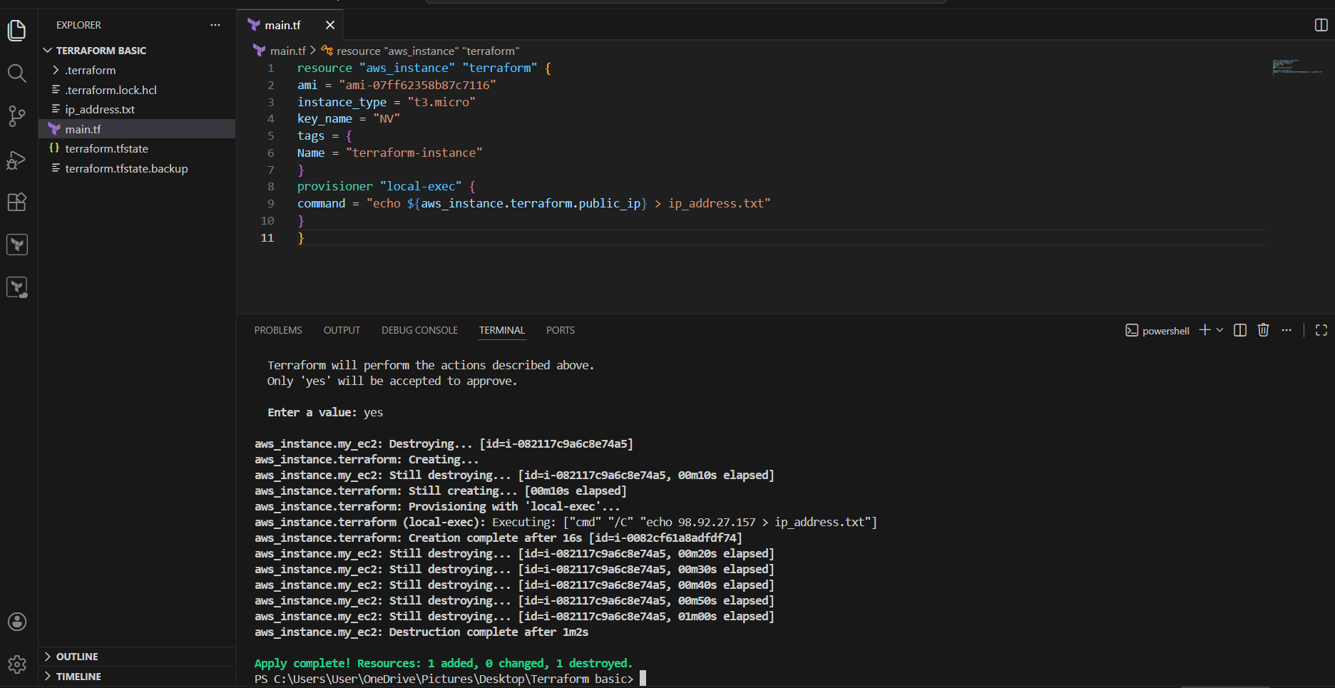
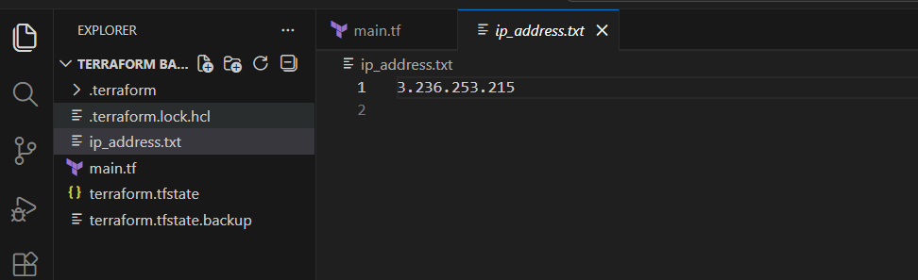
Step 11: Validate Resource Changes
- Terraform output showed:
  - 1 resource added
  - 1 resource changed
  - 1 resource destroyed (due to re-creation)
- AWS Console reflected updated EC2 instance state
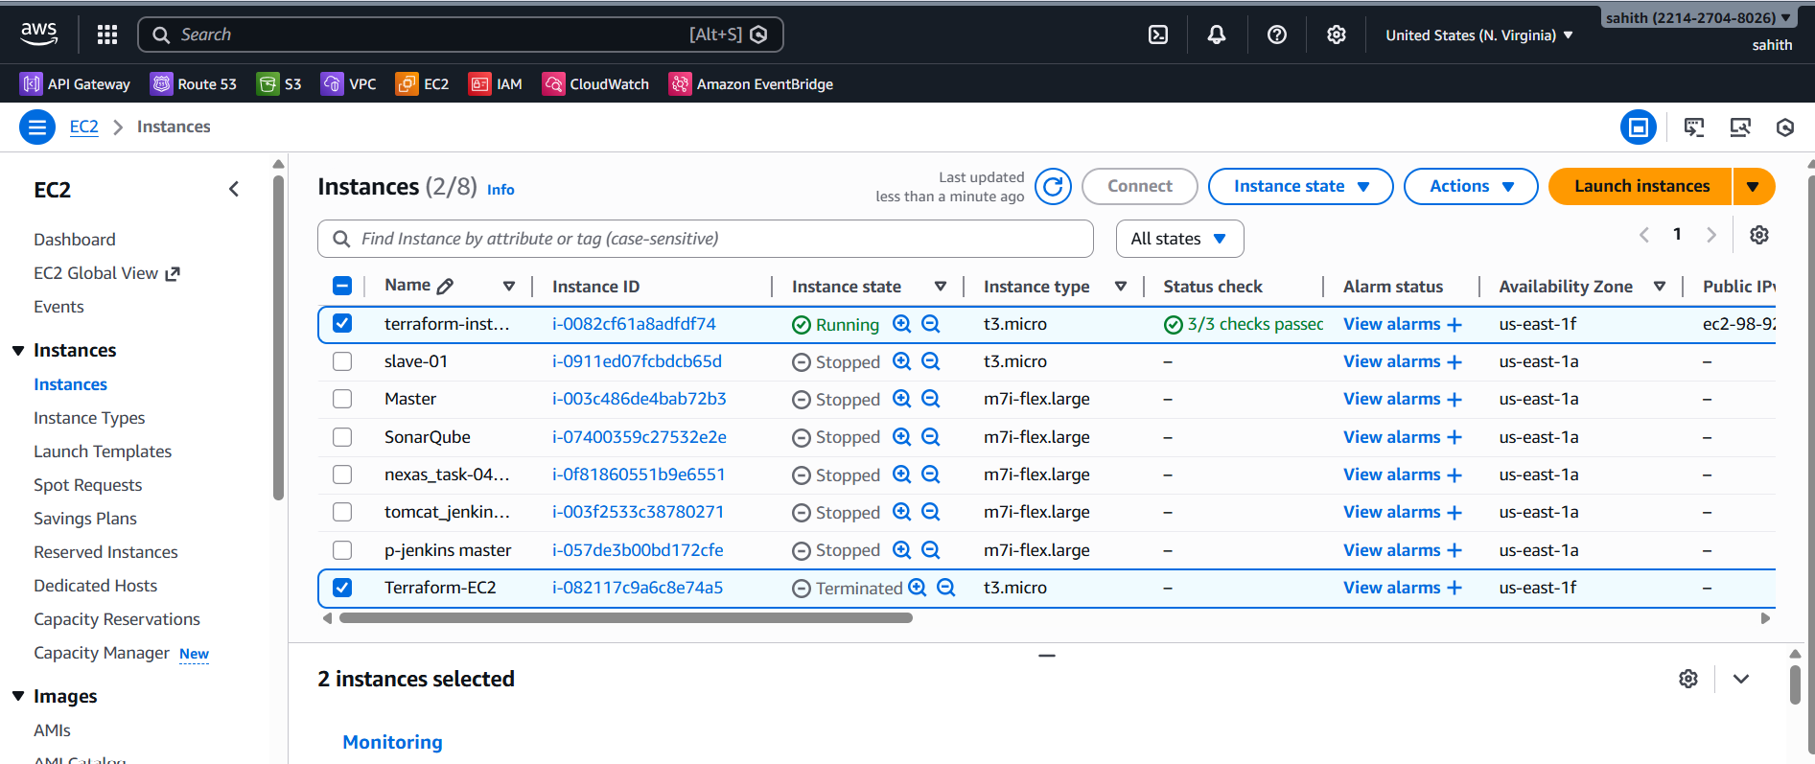
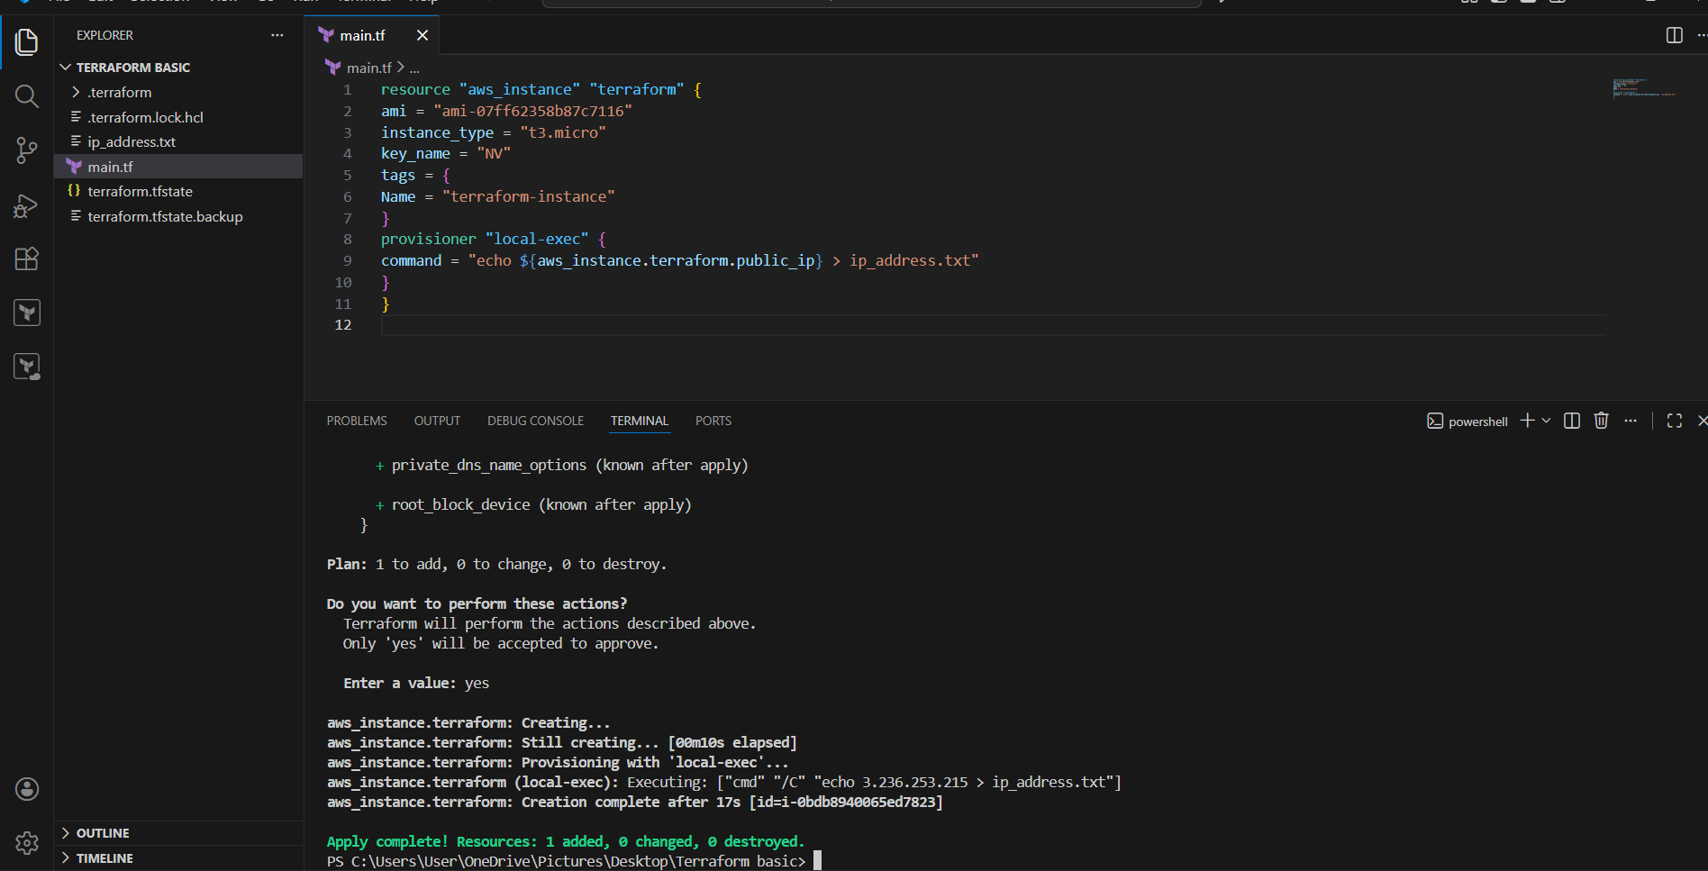
Validation Steps
- S3 bucket visible in AWS S3 Console
- DynamoDB table visible and active
- EC2 instance visible in EC2 dashboard
- EC2 instance reachable via public IP
- ip_address.txt file created locally with correct IP
Issues Faced
- Deprecated acl warning for S3 bucket
- Multiple resource recreations due to configuration updates
- Region alignment required for backend resources
- Backend initialization required correct resource existence
Conclusion
Terraform was successfully used to provision AWS infrastructure components and an EC2 instance. All resources were verified at the AWS GUI level. The exercise demonstrated end-to-end infrastructure automation, backend configuration, and post-provisioning automation using provisioners.

Task Title
Create One EC2 Instance with HTTPD Installed Using Terraform
Objective
To provision an AWS EC2 instance using Terraform, automatically install and start the Apache HTTP server (httpd) using a user data script, capture the public IP address, and verify web access through a browser.
Prerequisites
- AWS account with required permissions
- Terraform installed
- AWS CLI configured
- Visual Studio Code installed
- Existing EC2 key pair
- Internet connectivity
- Default VPC and subnet available in the selected region
Steps Performed
Step 1: Open Terraform Project in Visual Studio Code
- Opened the Terraform project directory in Visual Studio Code
- Opened the main.tf file for editing
Step 2: Define EC2 Instance Resource
- Created an aws_instance resource named httpd
- Configured the EC2 instance with:
  - Amazon Linux AMI
  - Instance type t3.micro
  - Key pair name
- Added a tag with the name httpd-instance for identification
Step 3: Configure User Data Script
- Added a user_data block to automate server configuration
- Script actions:
  - Update system packages
  - Install Apache HTTP server (httpd)
  - Start the httpd service
  - Enable httpd to start on boot
  - Create an index.html file displaying a “Hello, World” message with the hostname
Step 4: Configure Local-Exec Provisioner
- Added a local-exec provisioner inside the EC2 resource
- Configured the provisioner to write the EC2 public IP address to a local file named ip_address.txt
Step 5: Initialize Terraform
- Executed terraform init from the terminal
- Terraform initialized successfully and downloaded required providers
Step 6: Review Terraform Execution Plan
- Terraform generated an execution plan
- Plan indicated:
  - 1 resource to add
  - Existing instance scheduled for replacement (if any)
Step 7: Apply Terraform Configuration
- Ran terraform apply
- Confirmed execution by entering yes
- Terraform destroyed the previous instance (if present) and created a new EC2 instance
Step 8: Monitor EC2 Creation and Provisioning
- Terraform showed the EC2 instance progressing through creation
- User data script executed automatically during instance boot
- Local-exec provisioner executed after creation to capture the public IP
Step 9: Capture EC2 Public IP Address
- Terraform created the file ip_address.txt
- File contained the public IP address of the newly created EC2 instance
Step 10: Verify Web Server Functionality
- Copied the public IP from ip_address.txt
- Opened a web browser and accessed:
- http://<public-ip>
- Verified the Apache web page displaying:
Hello, World from <hostname>
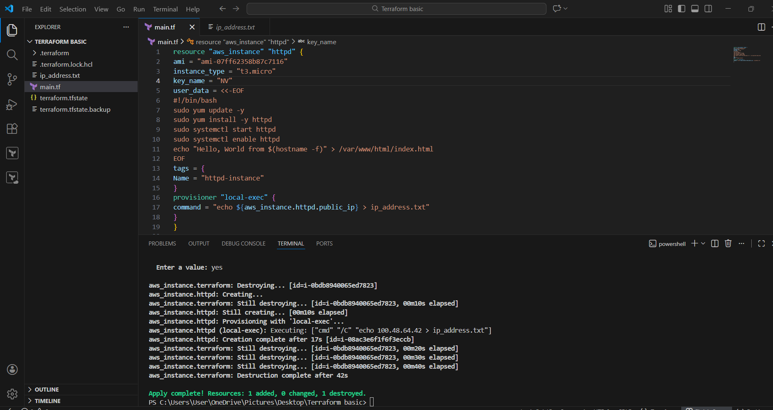
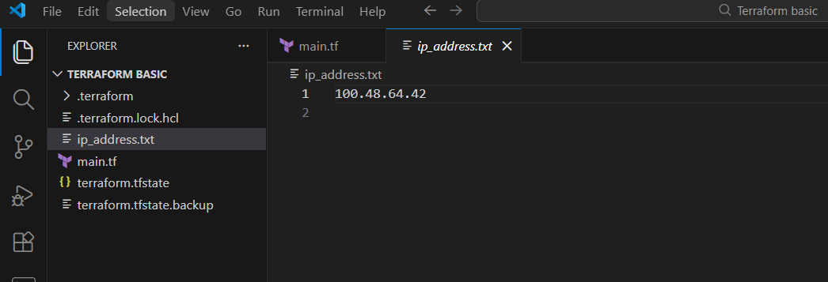
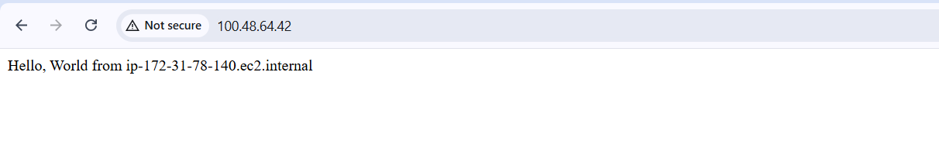

Task Title
Set up an S3 backend and create infrastructure using Terraform
Objective
- Create an EC2 instance using Terraform
- Create an S3 bucket using Terraform
- Configure the S3 bucket as a remote backend for Terraform state
- Verify that the Terraform state file is stored in S3
Prerequisites
- AWS account with required permissions
- AWS CLI installed and configured (aws configure)
- Terraform installed
- Visual Studio Code installed
- Existing key pair (NV) in us-east-1 region
Steps Performed
Step 1: Open Terraform Project in VS Code
- Opened the project folder TERRAFORM BASIC in Visual Studio Code
- Verified presence of files:
  - main.tf
  - .terraform/
  - terraform.lock.hcl
  - terraform.tfstate
  - terraform.tfstate.backup
  - ip_address.txt
Step 2: Define EC2 Instance with HTTPD Installation
- Added an aws_instance resource named httpd
- Used:
  - Instance type: t3.micro
  - Key pair: NV
- Added user_data script to:
  - Update packages
  - Install httpd
  - Start and enable httpd
  - Create a web page at /var/www/html/index.html
- Tagged the instance as httpd-instance
Step 3: Capture Public IP Using Local-Exec
- Added a local-exec provisioner
- Stored the EC2 public IP in a local file:
  - ip_address.txt
Step 4: Create an S3 Bucket Using Terraform
- Added an aws_s3_bucket resource
- Bucket name used:
  - techiehorizonbucketbhjd
- Applied the configuration successfully
- Verified bucket creation in AWS Console
Step 5: Configure S3 as Terraform Backend
- Added a terraform backend block:
  - Backend type: s3
  - Bucket: techiehorizonbucketbhjd
  - Key: terraform.tfstate
  - Region: us-east-1
- Re-initialized Terraform using:
- terraform init
Step 6: Apply Terraform Configuration
- Ran:
- terraform apply
- Approved the execution by typing yes
- Terraform created the required resources successfully
Step 7: Verify Terraform State in S3
- Opened AWS S3 Console
- Navigated to bucket techiehorizonbuck
- Confirmed presence of:
  - terraform.tfstate file
- This confirms remote backend is working correctly
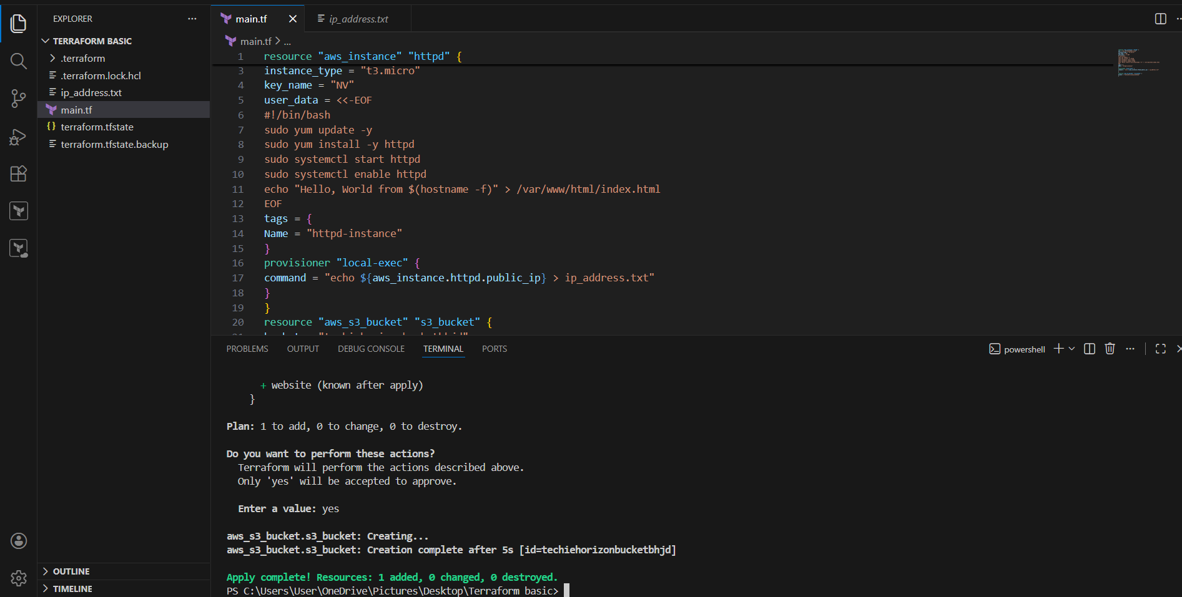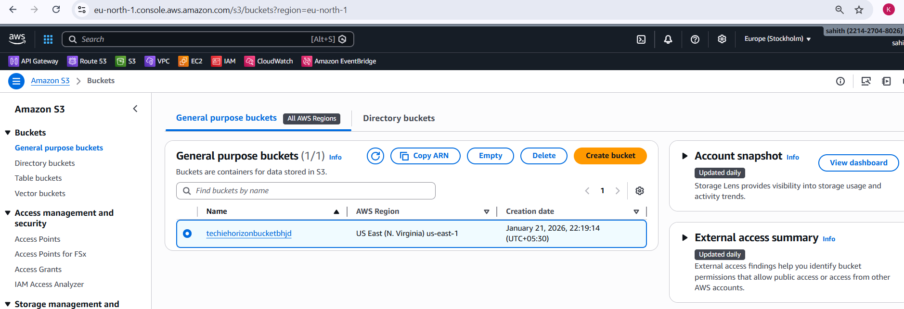
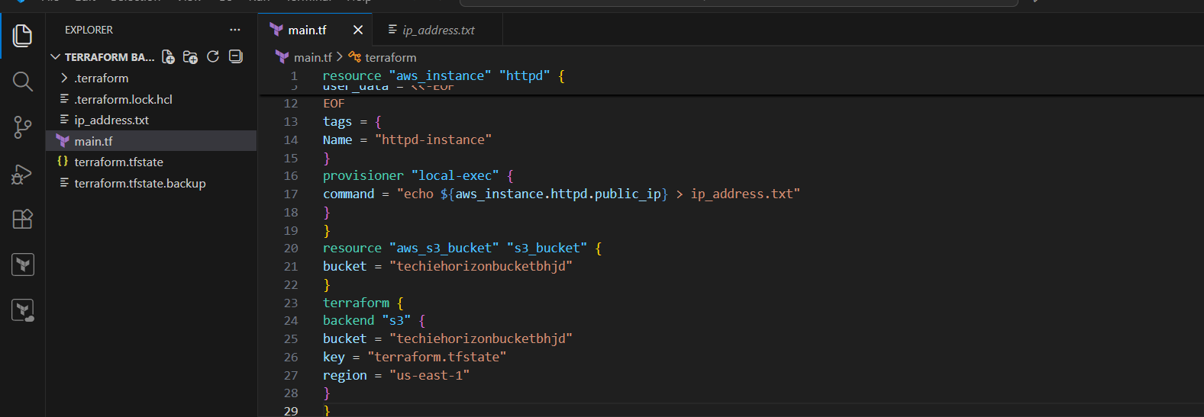
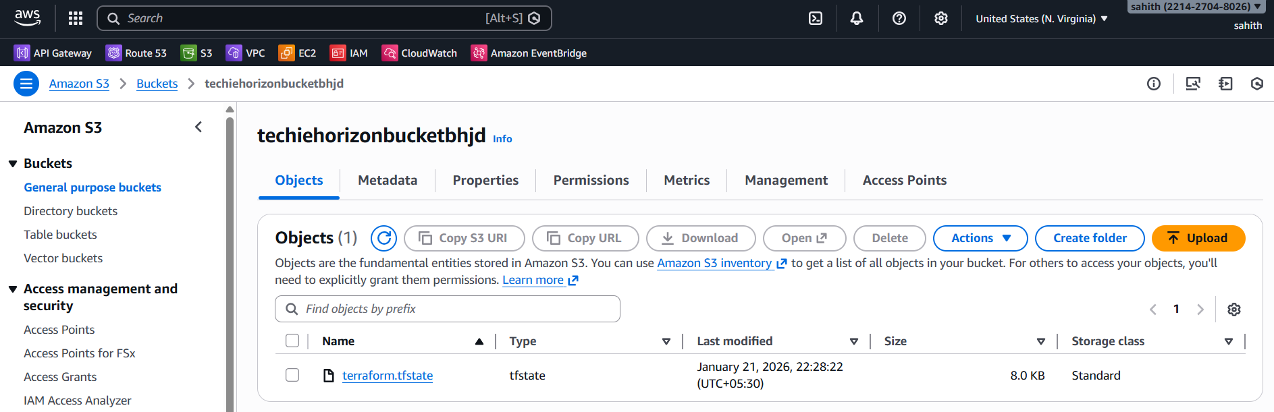

Validation Steps
- EC2 instance visible in AWS EC2 Console (Running state)
- HTTP service accessible using EC2 public IP
- ip_address.txt contains the correct public IP
- terraform.tfstate stored in S3 bucket
- Terraform backend initialized successfully
Issues Faced
- Initial backend and region mismatches (resolved)
- Deprecated ACL warnings for S3 (non-blocking)
- Backend reinitialization required after changes
Conclusion
- Successfully created an EC2 instance with HTTPD installed using Terraform
- Successfully created and verified an S3 bucket
- Configured S3 as a remote backend for Terraform state
- Infrastructure and state management are fully operational and verified at AWS GUI level

5. Set up DynamoDB locking for task 3.
Task Title
Configure Terraform Remote Backend Using S3 and DynamoDB State Locking
Objective
To create a DynamoDB table for Terraform state locking, configure an S3 backend for remote state storage, and successfully initialize Terraform using the remote backend.
Prerequisites
- AWS account with access to S3 and DynamoDB
- AWS CLI configured (aws configure)
- Terraform installed
- Visual Studio Code with Terraform files
- Proper IAM permissions for S3 and DynamoDB
Steps Performed
Step 1: Create DynamoDB Table for State Locking
- Defined a DynamoDB table resource in main.tf.
- Table name set to terraform-state-lock-dynamo.
- Configured:
  - Partition key: LockID
  - Attribute type: String (S)
  - Read capacity: 20
  - Write capacity: 20
- Executed terraform apply.
- Terraform successfully created the DynamoDB table.
- Verified the table in AWS DynamoDB console (Status: Active).
Step 2: Verify DynamoDB Table in AWS Console
- Navigated to DynamoDB → Tables in the AWS console.
- Confirmed the table terraform-state-lock-dynamo exists.
- Verified partition key LockID and table status as Active.
Step 3: Configure Terraform S3 Backend
- Added a terraform backend block in main.tf.
- Configured backend as:
  - Backend type: s3
  - Bucket name: s3carbucket
  - Key: terraform.tfstate
  - Region: eu-north-1
  - DynamoDB table: terraform-state-lock-dynamo
- This configuration enables:
  - Remote state storage in S3
  - State locking via DynamoDB
Step 4: Initialize Terraform Backend
- Ran the command:
- terraform init
- Terraform initialized the S3 backend.
- Provider plugins were downloaded.
- Terraform confirmed backend initialization was successful.
Step 5: Verify Remote State Storage
- Navigated to Amazon S3 → Buckets in the AWS console.
- Opened the bucket s3carbucket.
- Verified that terraform.tfstate file was created inside the bucket.
- Confirmed Terraform state is now stored remotely.



Validation Steps
- DynamoDB table exists and is active.
- Terraform initializes without backend errors.
- terraform.tfstate is present in the S3 bucket.
- State locking is enabled using DynamoDB.
Issues Faced
- Warning observed: acl is deprecated.
  - Explanation: acl argument in aws_s3_bucket is deprecated.
  - Terraform execution still completed successfully.
- No blocking errors encountered.
Conclusion
Terraform remote backend was successfully configured using S3 for state storage and DynamoDB for state locking. Terraform initialization completed successfully, and the state file is securely stored in S3 with concurrency protection enabled through DynamoDB.

Overall Task Conclusion
By completing this task, Terraform was successfully used to provision cloud infrastructure in AWS. An EC2 instance was created and automatically configured with Apache using a Terraform script. Terraform state was securely stored in an S3 bucket, and DynamoDB was configured to provide state locking, preventing concurrent modifications. This setup follows Terraform best practices and demonstrates real-world DevOps automation using AWS and Terraform.

